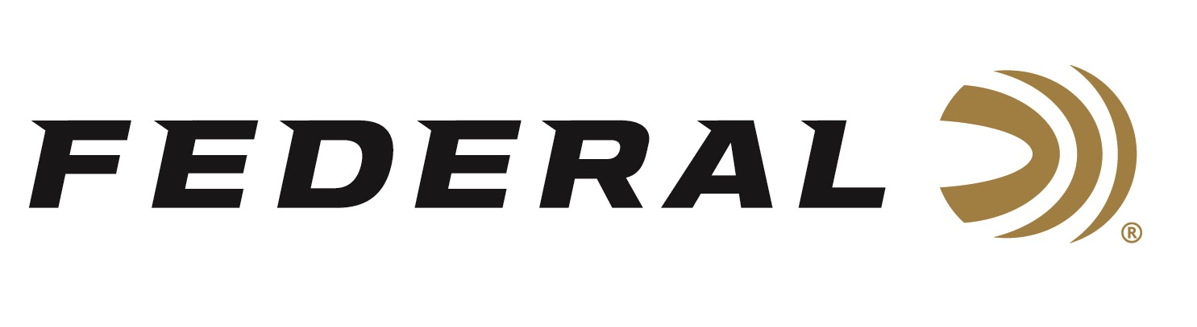

FOR IMMEDIATE RELEASE

Several Team Federal Podium Finishes at World English Sporting Clay Championship

ANOKA, Minnesota – April 28, 2026 – In a strong international field of nearly 1,300 shooters at the World English Sporting Clay Championships, Team Federal finished with multiple trophies. Two-time Olympian Derrick Mein finished the Main Event High Over All in third place. The World English Sporting Clay Championships took place at the World Shooting Complex in San Antonio, TX. The event drew competitors from around the globe and ran from April 21-26, 2026.

Mein, a Kansas native, earned a spot in the Super Final with five other competitors seeking a world title. With a strong showing in the final 25 clays, Mein moved up into a tie for second before falling to third in a shoot-off. Mein also had strong finishes in FITASC and the 5-Stand events with large fields including current and former World Champions.

Former National and World FITASC Champion Gregg Wolf claimed an event title at the World Shooting Complex in San Antonio. The Jordan, MN native won the American Field Sporting High Over All event in a shoot-off over 2025 World Preliminary Champion James Attwood from the United Kingdom. 250 shooters participated in the single event.

In the Junior Division, Jonathan Prince had several good showings. In both the Main Event and 5-Stand events, he finished in third place. Prince was a member of the United States Junior Team that defeated England and Ireland by 72 targets to claim the first place National Teams trophy.

Federal Ammunition products, including the new Master Class, are available at dealers nationwide and online. This competition-level sporting clay load features a customized Podium wad that extracts peak performance from utilizing Federal’s straight-wall hull, reliable primers, high-antimony lead shot, and select propellant. For more information on Master Class and all Federal products, visit www.federalpremium.com.

Federal Ammunition products are available at dealers nationwide and online. For more information on all Federal products and to sign up to receive notifications about new product availability, rebate promotions, and other brand news via email, visit www.federalpremium.com.

Press Release Contact: JJ Reich
Senior Manager – Press Relations
E-mail: media@tkghunt.com

About Federal Ammunition
Federal, headquartered in Anoka, MN, is an ammunition brand of The Kinetic Group, owned by CSG, a globally diversified industrial group based in Prague, Czech Republic. Since 1922, Federal has been a leader in ammunition innovation, delivering high-quality sporting and hunting products to shooters worldwide. With a commitment to conservation and the outdoor community, Federal continues to manufacture industry-leading ammunition that enhances the shooting experience while supporting outdoor traditions.

